PNEUMONIA DETECTION USING DEEP LEARNING
Block Diagrams (all)
Department of Computer Science and Engineering, TKR College of Engineering and Technology (Autonomous)
Batch A12 (CSE-A) · Academic year 2026-2027
Table 1: Project team
S.No. | Student name | Roll number
1 | CHOUDAM AKSHITHA | 23K91A0556
2 | BOGGULA SATVIK KUMAR | 23K91A0541
3 | ARUTLA ABHI THEJ REDDY | 23K91A0515
4 | DUGGARAJU LIKHITHA | 23K91A0565

Project guide: V. MEENAKSHI
Chapter and section numbers quoted in the text (for example Section 6.6 or Chapter 8) refer to the full project report, 17.Final Document. Figures and tables in this document are numbered from 1.

1. INDEX OF DIAGRAMS
Every diagram is generated from the real design by scripts/make_diagrams.py (matplotlib, 150 dpi) and mirrors the code in backend/main.py, app.py, model/ and database/.
Table 2: Diagrams in this document
No. | Diagram | Image file
1 | System architecture | docs/diagrams/01_system_architecture.png
2 | High-level workflow | docs/diagrams/02_high_level_workflow.png
3 | Data flow diagram, level 0 | docs/diagrams/03_dfd_level0.png
4 | Data flow diagram, level 1 | docs/diagrams/04_dfd_level1.png
5 | Data flow diagram, level 2 | docs/diagrams/05_dfd_level2.png
6 | UML class diagram | docs/diagrams/06_uml_class_diagram.png
7 | Sequence diagram | docs/diagrams/07_sequence_diagram.png
8 | Use-case diagram | docs/diagrams/08_use_case_diagram.png
9 | Entity-relationship diagram | docs/diagrams/09_er_diagram.png
10 | Flowchart of the core algorithm | docs/diagrams/10_core_algorithm_flowchart.png

2. DIAGRAMS

System architecture
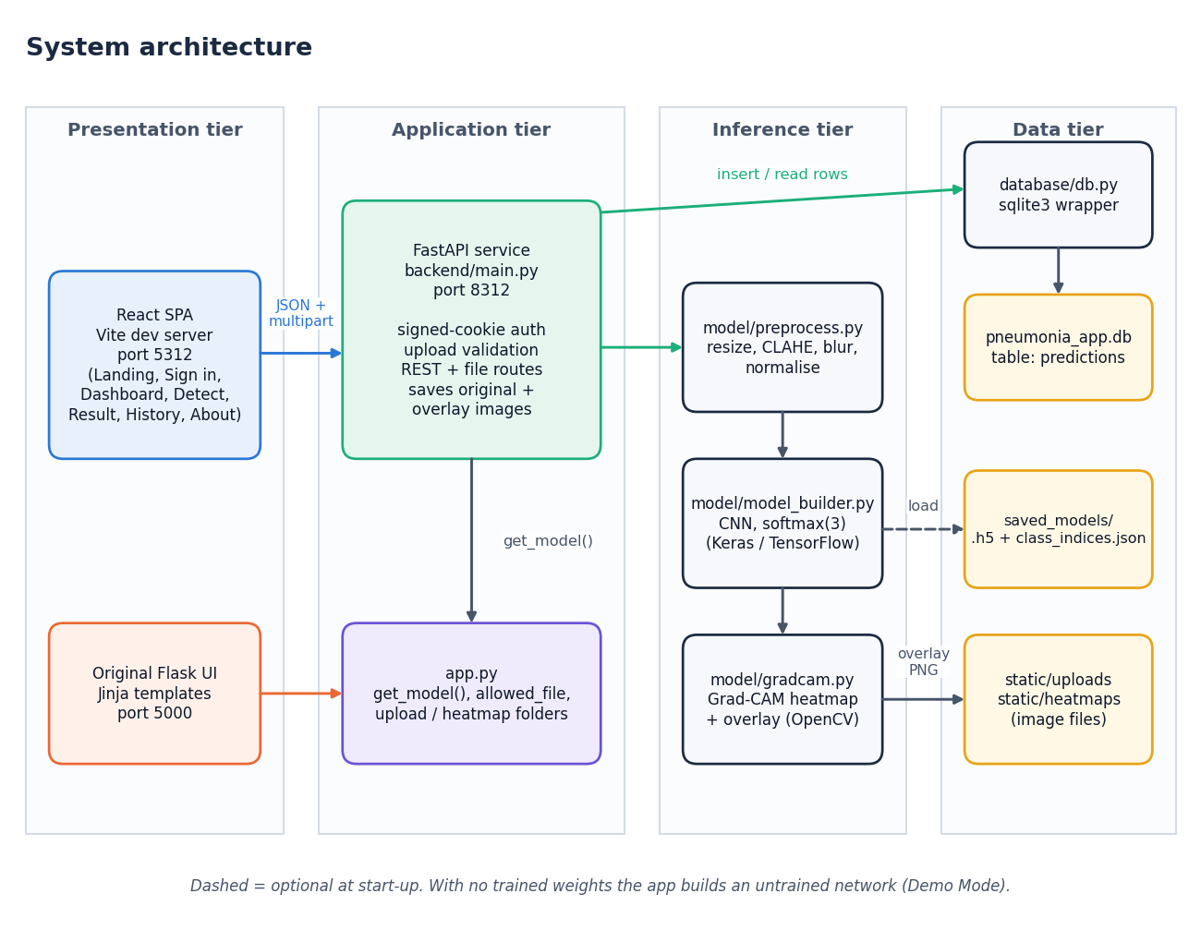
Figure 1: System architecture of the pneumonia detection system
The system has four tiers. In the presentation tier the React single-page application (served by the Vite development server on port 5312) and the original Flask interface (port 5000) are the two ways a user reaches the system. The application tier is the FastAPI service in backend/main.py (port 8312), which authenticates the session cookie, validates uploads and exposes the REST and file routes; it imports app.py for the model loader and folder settings, so the model is loaded once and shared. The inference tier is the three modules that do the actual work: preprocess.py turns an upload into a 224 x 224 tensor, model_builder.py defines the CNN and gradcam.py produces the heat map. The data tier holds the SQLite database (pneumonia_app.db, table predictions), the saved original and overlay images, and the trained weights. When saved_models/ holds no weights the loader builds an untrained network and flags Demo Mode.

High-level workflow
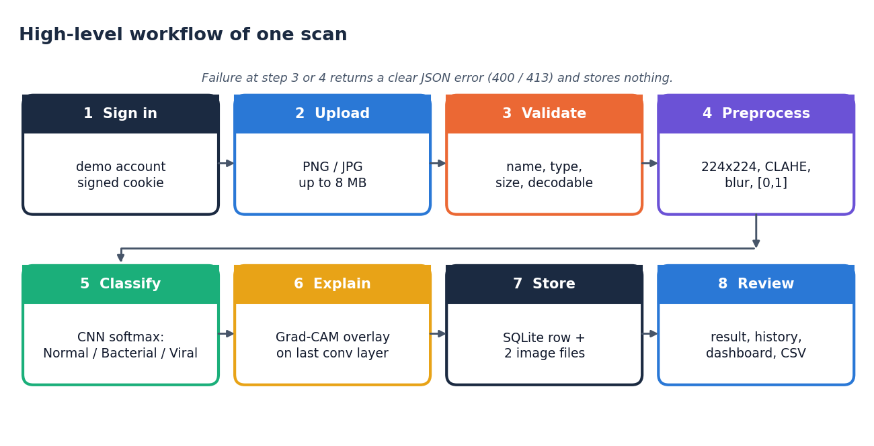
Figure 2: High-level workflow of one scan, from sign-in to review
A scan passes through eight steps. The user signs in, uploads a PNG or JPEG of at most 8 MB, and the server validates the name, type, size and that the file can be decoded. The image is preprocessed (224 x 224, CLAHE, light blur, scaling to [0, 1]) and classified by the CNN, whose softmax output gives the three class probabilities. Grad-CAM then explains the predicted class, and the record plus the two image files are stored. Finally the user reviews the result, the history and the dashboard. A failure at the validation or decoding step ends the flow with a JSON error and stores nothing.

Data flow diagram, level 0
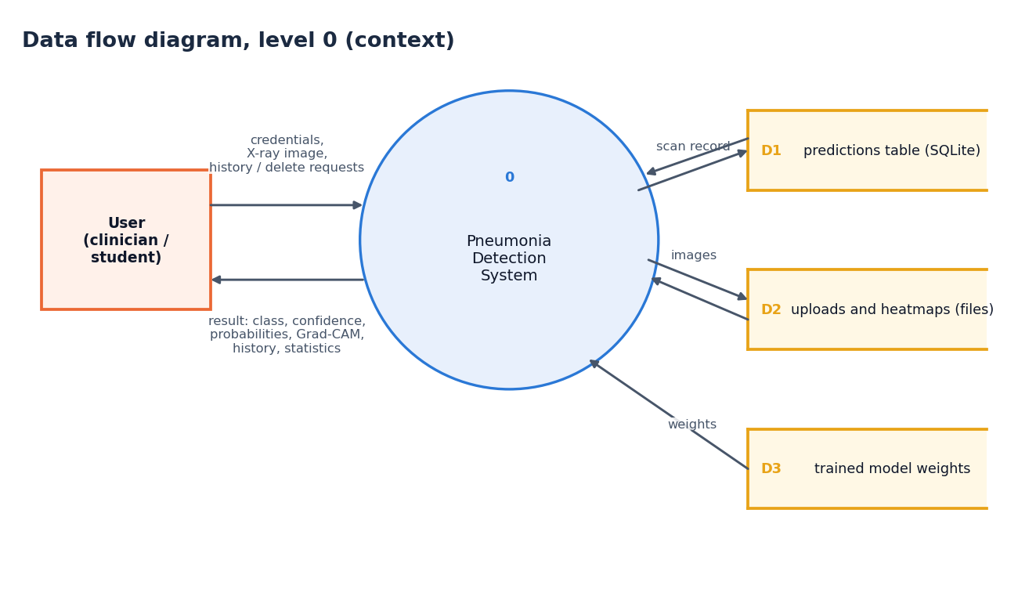
Figure 3: Data flow diagram, level 0 (context diagram)
The context diagram shows the system as a single process with one external entity, the user. The user sends credentials, X-ray images and history or delete requests; the system returns the classification result with its heat map, the history and the statistics. Internally the system reads and writes three data stores: the predictions table (D1), the uploaded and heat-map image files (D2) and the trained model weights (D3), which are only read.

Data flow diagram, level 1
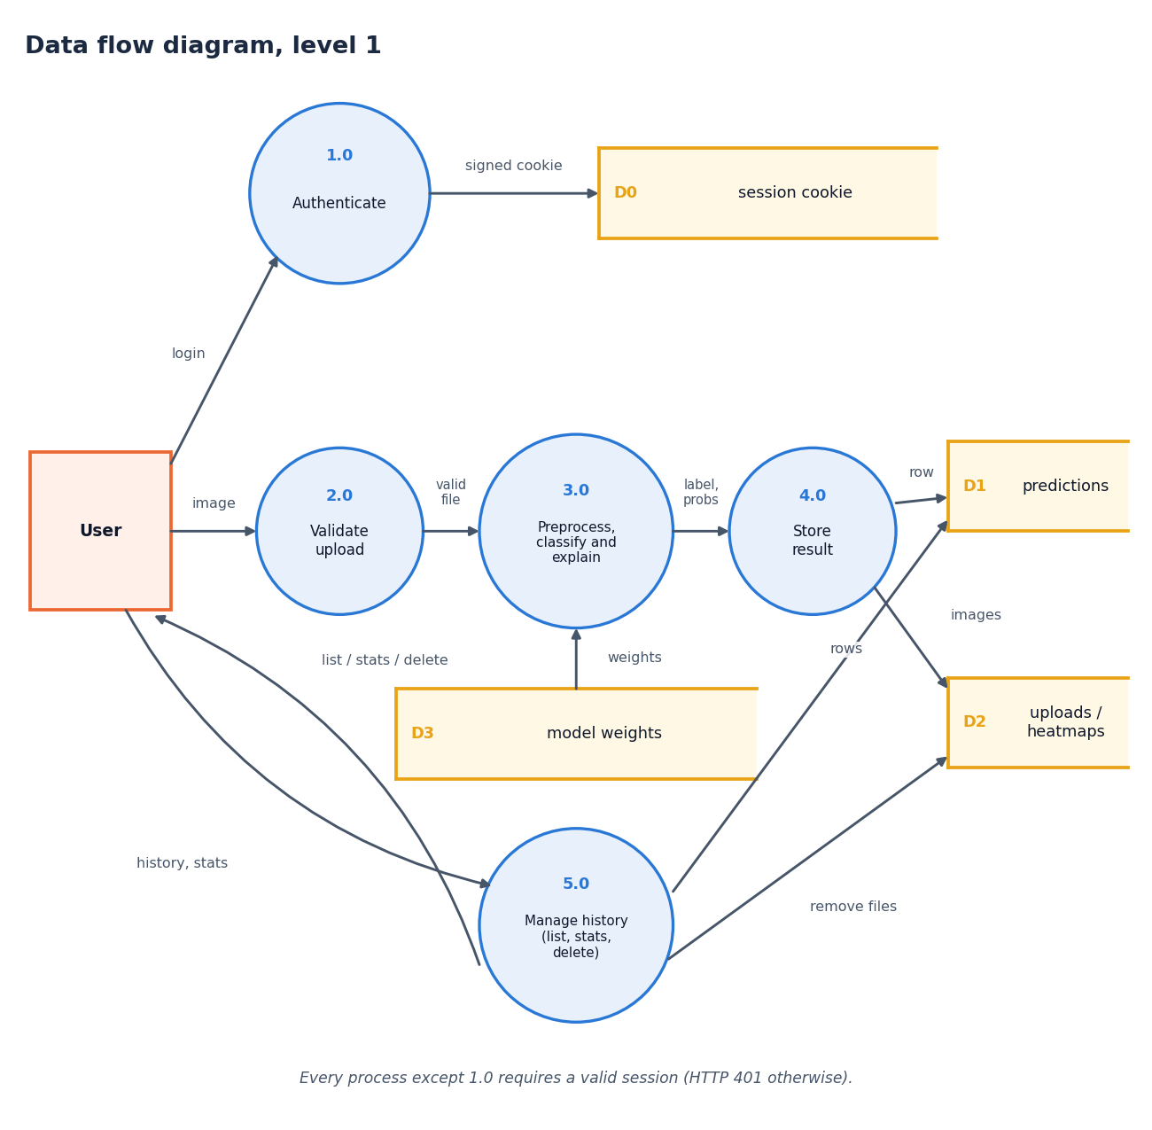
Figure 4: Data flow diagram, level 1
Level 1 splits the system into five processes. Authenticate (1.0) checks the credentials and sets a signed cookie (D0). Validate upload (2.0) accepts the image only if the cookie is valid, the extension is allowed, the size is within 8 MB and the file decodes. Preprocess, classify and explain (3.0) reads the model weights (D3) and returns the label, probabilities and overlay. Store result (4.0) writes one row to the predictions table (D1) and the two images to the file store (D2). Manage history (5.0) serves the list, the statistics and deletions, and removes the image files when a scan is deleted.

Data flow diagram, level 2
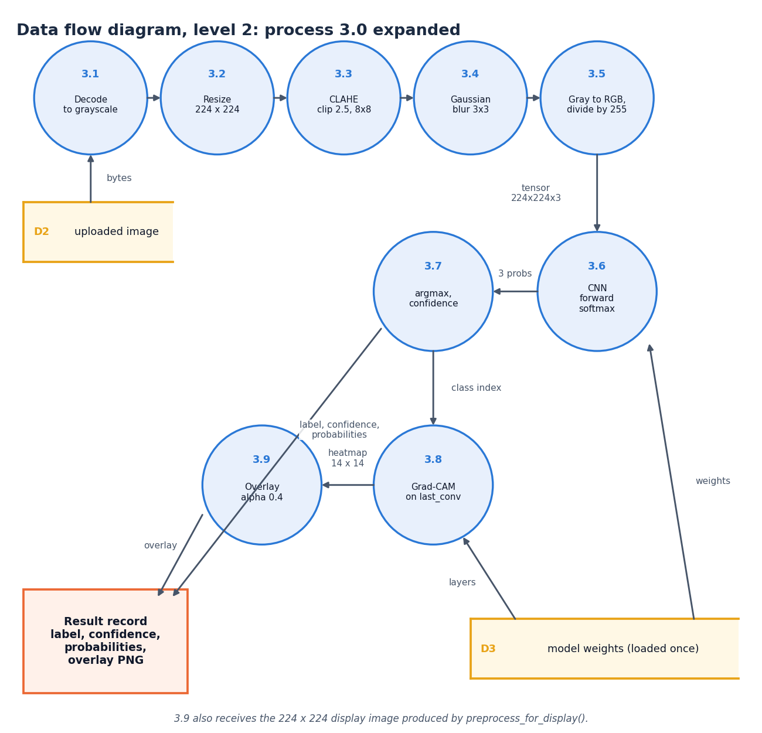
Figure 5: Data flow diagram, level 2: process 3.0 expanded
Level 2 expands the inference process into its nine steps, in the order the code executes them. The upload is decoded to grayscale (3.1), resized to 224 x 224 (3.2), enhanced with CLAHE (clip limit 2.5, 8 x 8 tiles; 3.3), smoothed with a 3 x 3 Gaussian (3.4) and converted to three channels scaled to [0, 1] (3.5). The network produces three probabilities (3.6); the arg-max and its probability become the label and confidence (3.7). The class index drives Grad-CAM on the last convolutional layer (3.8), whose 14 x 14 map is blended at alpha 0.4 over the display image (3.9). The result record carries the label, confidence, probabilities and the overlay image.

UML class diagram
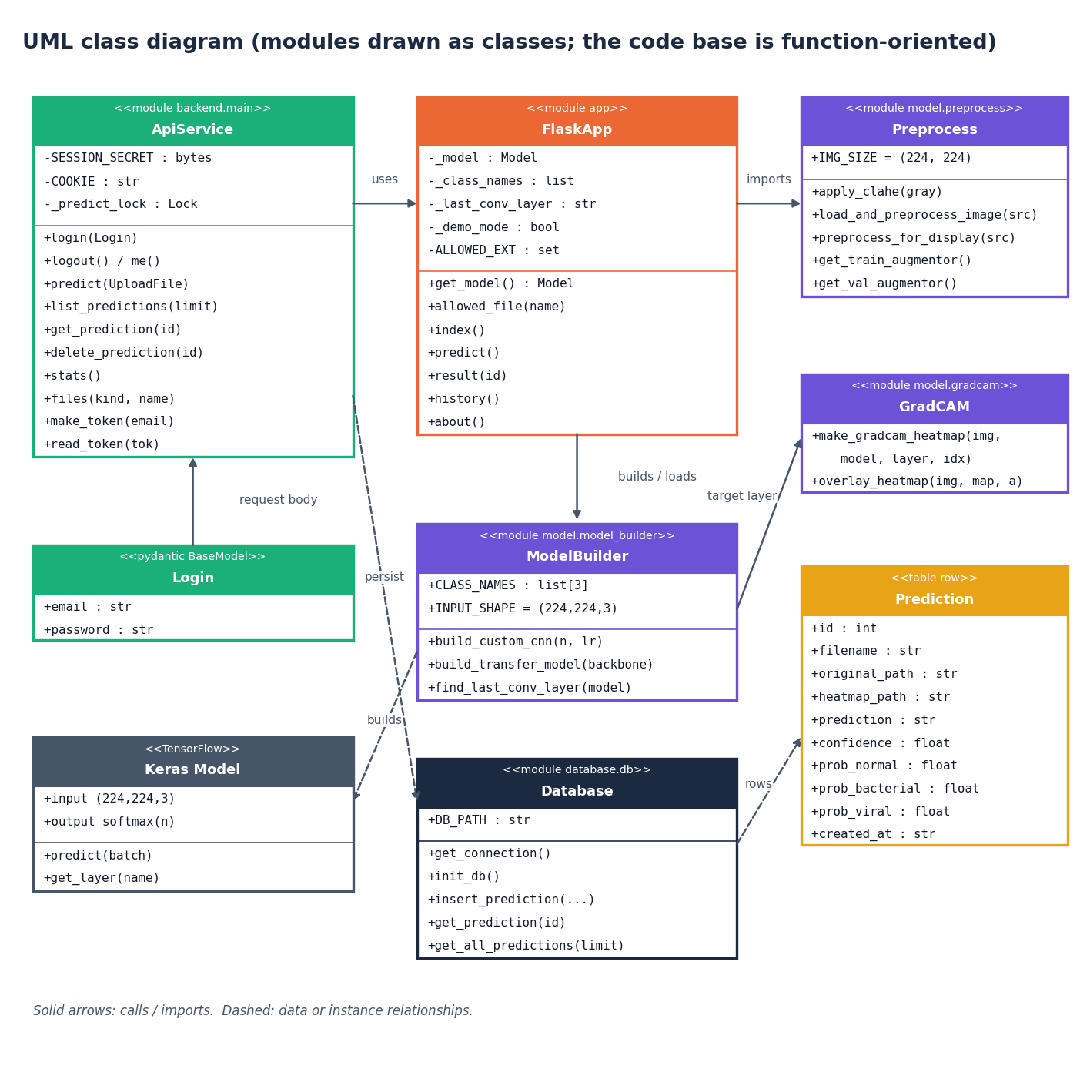
Figure 6: UML class diagram (modules drawn as classes)
The code base is function-oriented, so the diagram draws each Python module as a class stereotyped as a module, listing its constants and public functions. ApiService (backend/main.py) uses FlaskApp (app.py) for the model loader and imports Preprocess; FlaskApp builds or loads the network through ModelBuilder, which creates Keras models, and GradCAM receives the name of the last convolutional layer from ModelBuilder. Database persists Prediction rows. Login is the only real class in the API layer (a Pydantic model that validates the sign-in body).

Sequence diagram
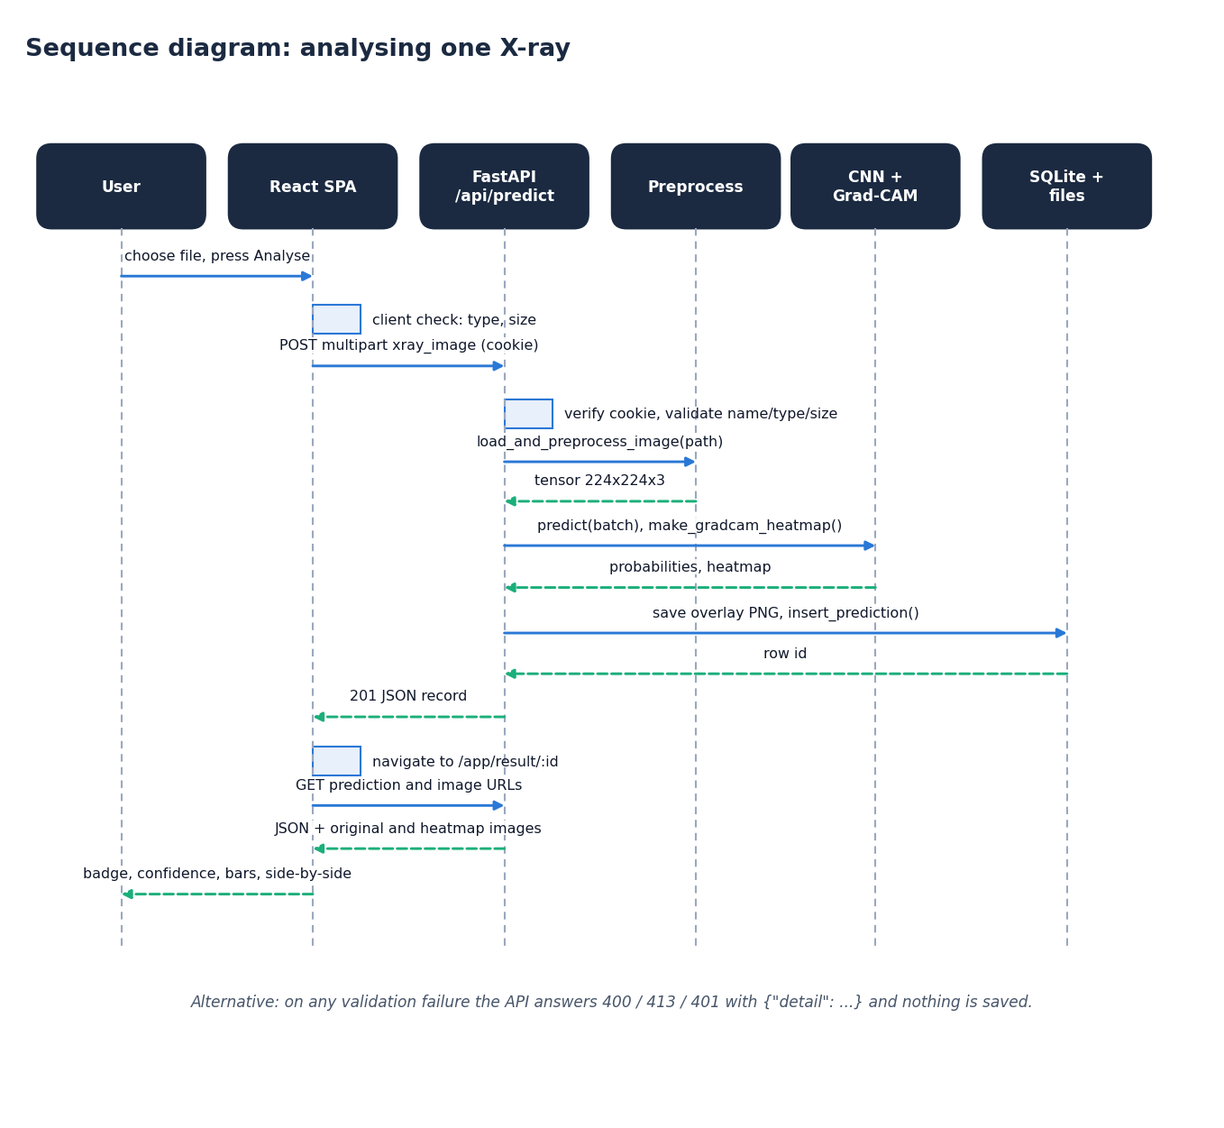
Figure 7: Sequence diagram: analysing one X-ray
The sequence follows one analysis. The React page checks the file type and size, then posts it as multipart data with the session cookie. The API verifies the cookie and validates the upload, calls the preprocessing function, and, under a lock that allows one TensorFlow inference at a time, runs the network and Grad-CAM. It writes the overlay image and the database row and returns HTTP 201 with the full record. The page then navigates to the result route, which fetches the record and the two images and renders the badge, confidence, bars and side-by-side view.

Use-case diagram
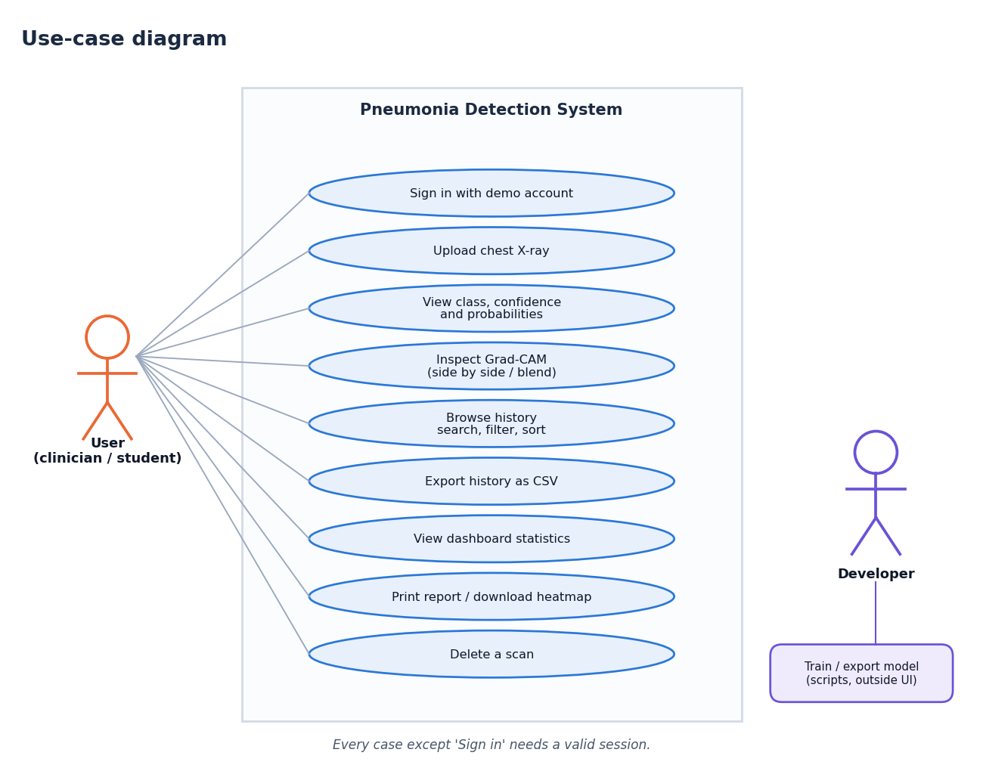
Figure 8: Use-case diagram
The user can sign in, upload an X-ray, view the class, confidence and probabilities, inspect the Grad-CAM overlay (side by side or blended), browse and filter the history, export it as CSV, view dashboard statistics, print the report or download the heat map, and delete a scan. Every case except signing in requires a valid session. The developer is a second actor who trains and exports a model with the scripts, outside the web interface.

Entity-relationship diagram
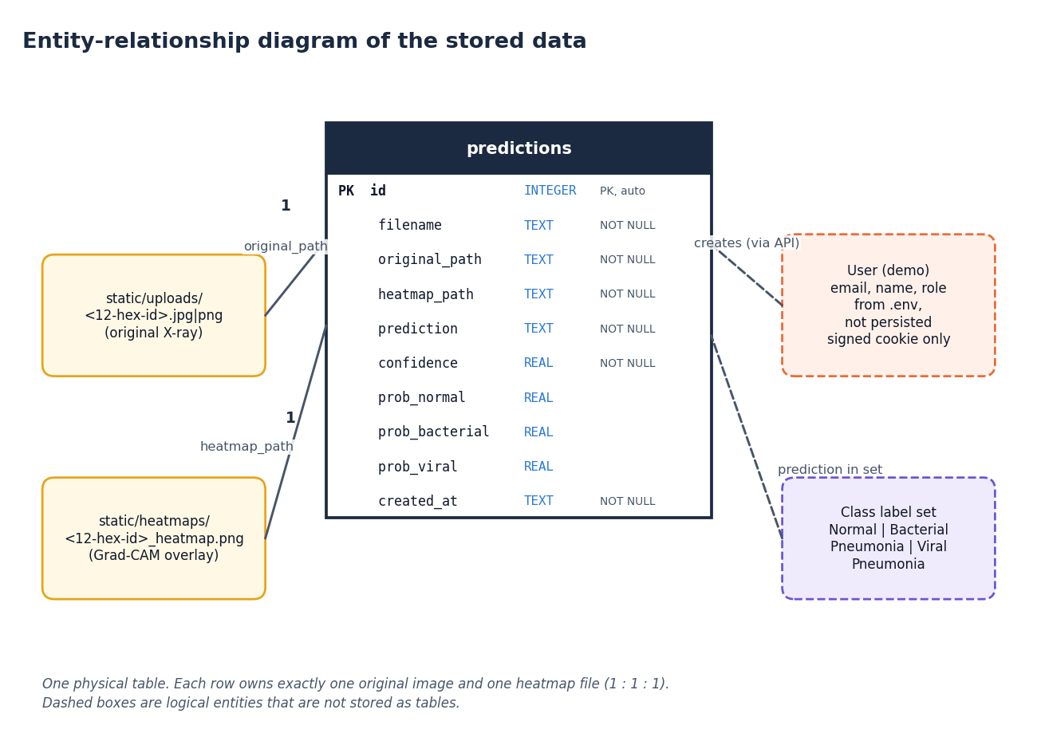
Figure 9: Entity-relationship diagram of the stored data
All persistent data are in one table, predictions, with ten columns. Each row owns exactly one original image in static/uploads/ and one overlay in static/heatmaps/, referenced by relative path, so the relationship between a row and its files is one to one to one. The demo user and the class label set are logical entities: the user is configured through the environment and carried only in a signed cookie, and the label set is the fixed list of three class names.

Flowchart of the core algorithm
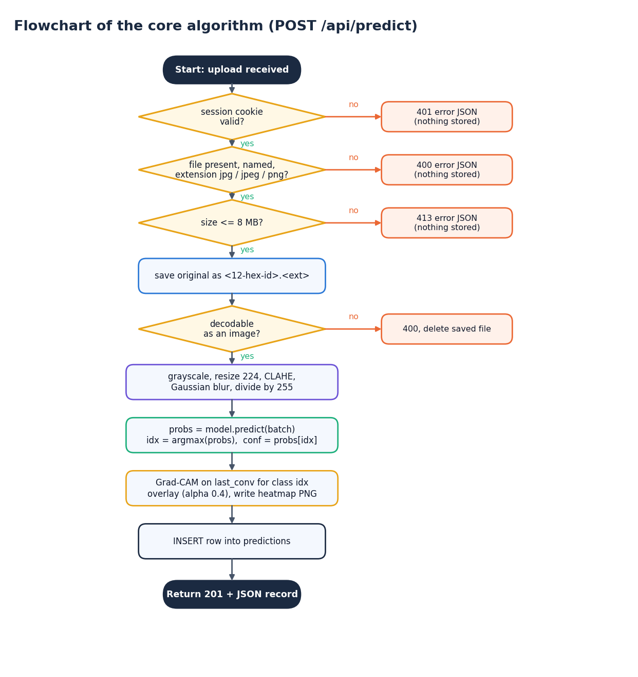
Figure 10: Flowchart of the core algorithm (POST /api/predict)
The flowchart gives the decisions of the prediction route in order: valid session (401 otherwise), a named file with an allowed extension (400), size within 8 MB (413), save under a random 12-character name, decodable image (400, and the saved file is deleted). It then preprocesses, predicts, takes the arg-max, runs Grad-CAM, writes the overlay, inserts the row and returns 201 with the record. The order matches backend/main.py and the Flask route.

